Data Base System

Lec-1

What is database?

It's a collection of organized data on a system that can be accessed, updated, managed easily by computer program.

Why do we need this database?

Suppose, there is no such database system in college's. Accessing info of particular student among hundreds would be a difficult task. An individual has to manually search through all the records of students till they find the relevant person, and accessing his/her info on grades would be more complicated.

Maintaining Database overcomes these problems. Users can just type in and get all the information regarding the relevant person quickly without any effort. This saves the valuable time.

Why we should learn database?

* Web developer
* Android app developer
* To handle database system of a company/ office (DBA)

The simplest answer is we need databases b/c they organize data in a manner which allows us to query data, sort data, and manipulate data in various ways. Database systems are changing, the theory of set data is changing, relational data modeling has changed, but the fundamental concept that we have to have a way to store data about customers, about products, about people, about “things”, etc… will always be there.

Lec-2

**Topic: Introduction to Database**

1. What is data?

Data🡪 Plural form of Latin word Datum

**Unprocessed or meaningless fact = Data**

* **Data** (or datum – a single unit of data) requires interpretation to become [information](https://en.wikipedia.org/wiki/Information). To translate data to information, there must be several known factors considered.
* **Data** is a collection of facts, such as numbers, words, measurements, observations or even just descriptions of things.

Example:

17 18

Female Hasina Rahim

Age 3.44 Roll city male

4.50 Dhaka 101 GPA

102 Sylhet Gender

1. What is information?

**Information** is knowledge about a particular subject, issue, event or process. **Information** can be obtained from various sources.

**Processed or meaningful information = Information**

Example:

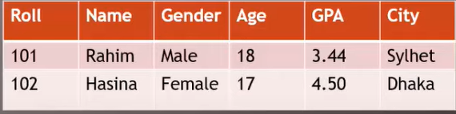

1. Difference between data and information

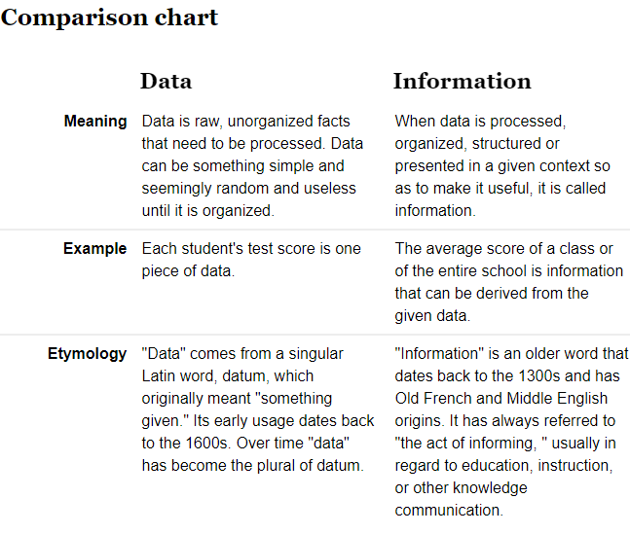

1. What is database?

Database = data + base

A **database** is an organized collection of [data](https://en.wikipedia.org/wiki/Data_(computing)), generally stored and accessed electronically from a computer system. Where databases are more complex they are often developed using formal [design and modeling](https://en.wikipedia.org/wiki/Database#Design_and_modeling) techniques.

Now a day’s database is using in the banks to store data.

Collection/ sum of Interrelated one or more data tables/ files is called database.

Example:

Correct Incorrect

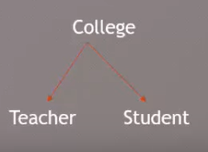 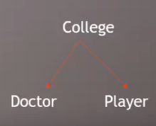

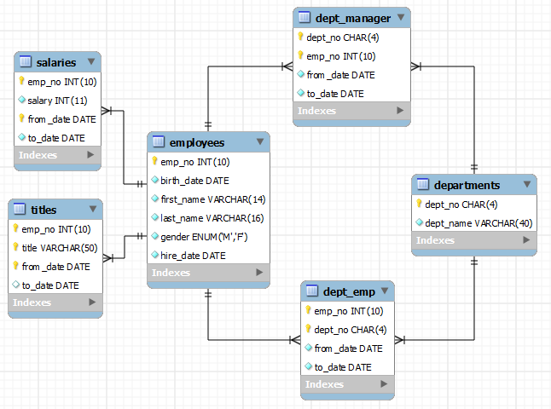

1. Advantage and disadvantages of using database?

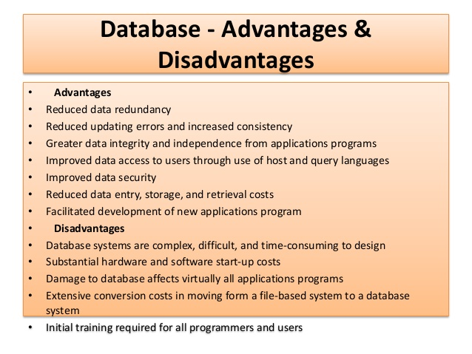

**Lec-3**

**Topic: Types of database**

1. Discuss about the types of database.

There are two types of database in term of structural:

* General Database

When there will be one file or more file (not interconnected)

Example:

This two tables are not related.

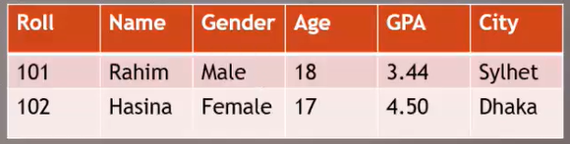

|  |  |  |  |
| --- | --- | --- | --- |
| No | Doctor | Teacher | Army |
| 1 | 45 | 64 | 23 |

* Relational Database

This type of database construct by using Interconnected files or tables.

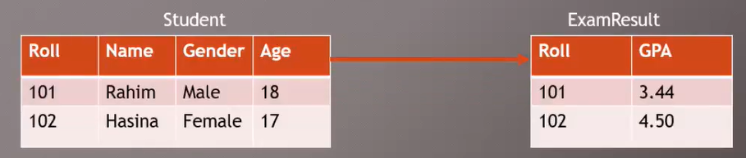

1. Discuss about the elements/components of database.

* Field (column)
* Record (row)
* Value(data)

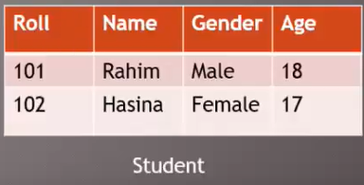

🡨 key field

1. Difference between field and record?

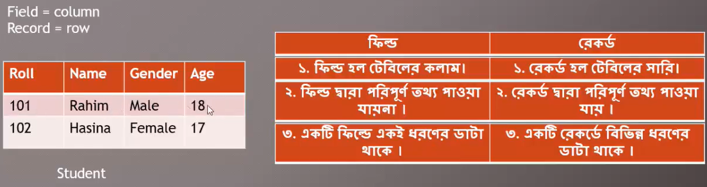

**Lec-4**

**Key Field**

1. What is key?

In a database table, a field is a data structure for a single piece of data. Fields are organized into records, which contain all the information within the table relevant to a specific entity.

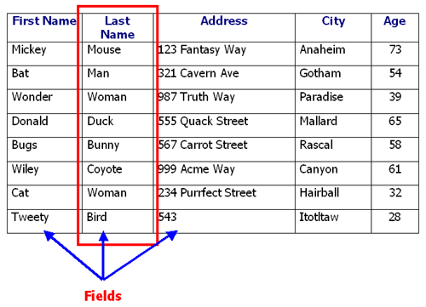

**Key field:**

A field in a record that holds unique data which identifies that record from all the other records in the file or database. Account number, product code and customer name are typical key fields. As an identifier, each key value must be unique in each record.

1. Classification of key.

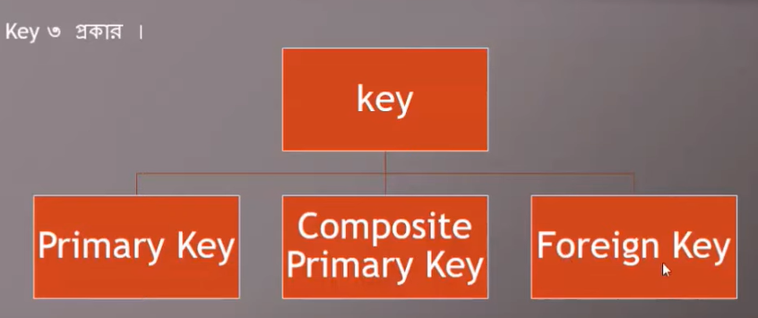

1. Difference between primary and foreign key.

Primary key:

A **primary key** is a *specific choice* of a *minimal* set of attributes ([columns](https://en.wikipedia.org/wiki/Column_(database))) that uniquely specify a tuple ([row](https://en.wikipedia.org/wiki/Row_(database))) in a [relation](https://en.wikipedia.org/wiki/Relation_(database)) ([table](https://en.wikipedia.org/wiki/Table_(database))).

Lec-11

DBMS= Database Management System

A Database Management System (DBMS) is a software that enables users to create and maintain database.

Some popular Example of DBMS: MySql, Oracle, Sybase, Microsoft Access and IBM DB2 etc.

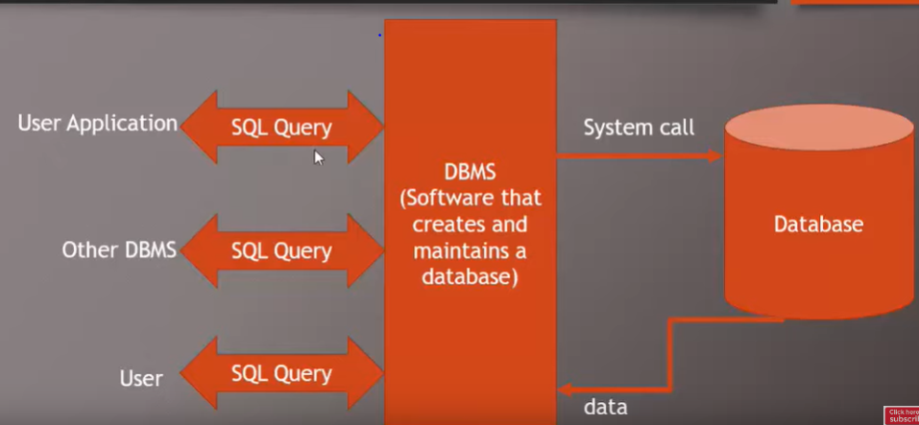

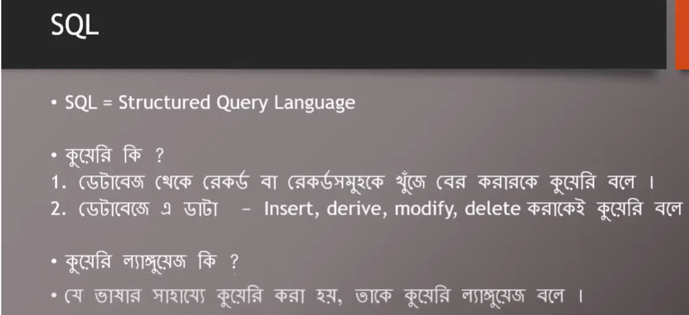

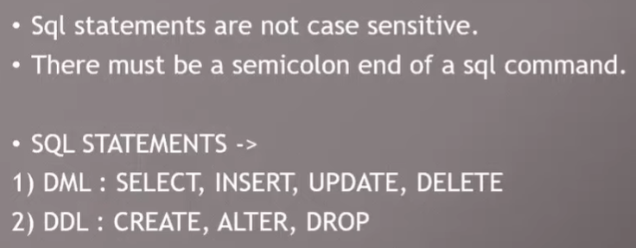

Data type:

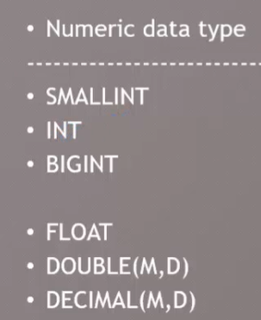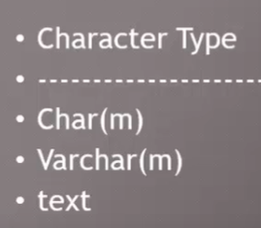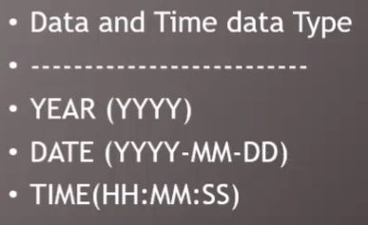

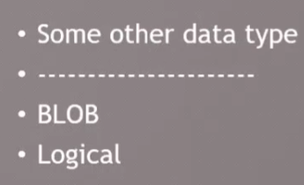

Lec-15

Table creating:

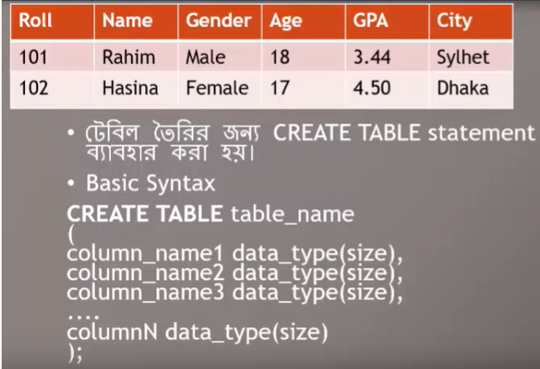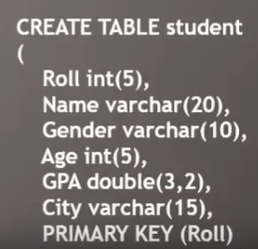

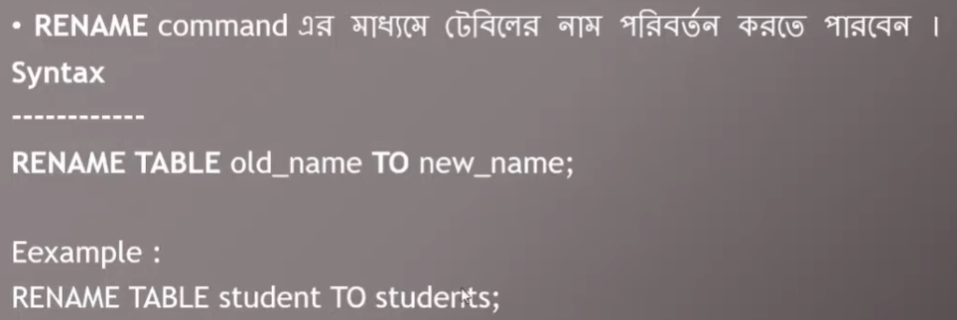

Data insertion:

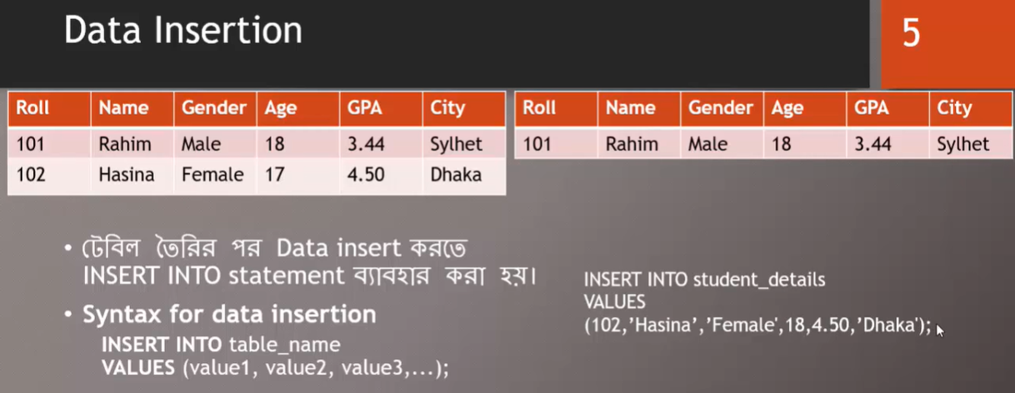

To insert all details together:

